34.104: 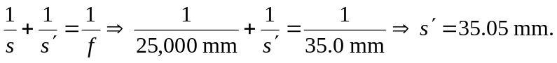
The resolution of 120 lines per millimeter means that the image line width is
0.0083 mm between lines. That is 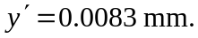But:
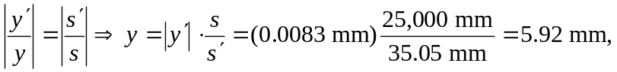 which is the minimum separation between two lines 25.0 m away from the camera.

